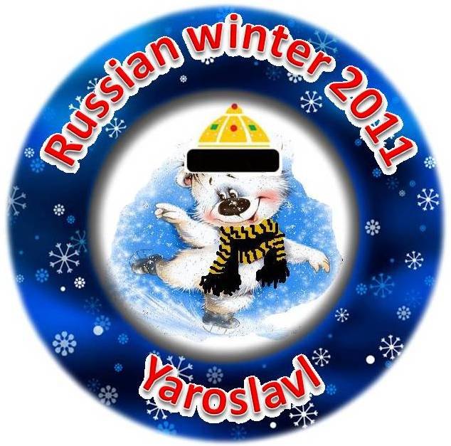
Form № 1 Entry form “Russian winter 2011” (25–27, February, 2011)
Surname, name:
- the participant
- the partner
Address
(country, town, address)
Telephone number, e-mail
Club (country)

Age (on the 1/02/2011)
Date of birth
Group “B”
FREE PROGRAM |  |  | INTERPRETIVE PROGRAM
( ) 1 level  ( ) 2 level  ( ) 3 level | ( ) 4 level  ( ) 5 level  ( ) 6 level | ( ) 7 level  ( ) 8 level  ( ) 9 level | Theme_________________________________________  ( ) 1- level ( ) 3 - level  ( ) 2 – level ( ) 4 - level

I (surname, name) ___________________________________________________ , being the parent of the participant
(surname, name)_____________________________________________________ agree with the Regulars and I’m informed about the Requirements of elements of the competition “Russian Winter 2011” (25 - 27, February, 2011). Date:_______________ Signature:_______________________
LIABILITY FORM
I (surname, name) ___________________________________________________ , being the parent of the participant
(surname, name)_____________________________________________________ agree to assume all risk of injury to my child and my property resulting from, caused by or connected with the conducting and management of the competition “Russian Winter 2011” (25–27, February, 2011). Date:_______________ Signature:_______________________

Form № 2 Total list - “Russian winter 2011” (25–27, February, 2011)
Surname, name:
the participant
1. ENTRY FEES 2. PRACTICIES
Event | Price  (rub/pers) | Your booking price | Day  (payment after arrival) | Your booking  “+”
First singles event | 2500 |  | 26th, February, 2011 – morning – 30 min
Second singles event | 1500 |  | 27th, February, 2011 – morning – 30 min
Total |  | ________
3. ENTERTAINMENT PROGRAMS 4. TRANSFERS
Programe | Price  (rub/pers) | Your booking price | Transfer | Price  (rub/pers) | Your booking  “+”
Sightseeing of Jaroslavl’ | 1500 |  | Transfer 1 (by train) – “Arriving – Departure”  (Moscow – Jaroslavl’ – Moscow) | 1200*
 |  |  | Transfer 4 (by bus)  Recommended hotels - skating-rink - 2roads | 500*
Total |  | _______ | Total |  | _____
5. ACCOMODATION in the hotel of the Organizing Committee (2*)
Standard room – DBL / SNGL | 3000 rub/day |  | Nights ____ | Lux – DBL / TRPL room | 5500 rub/day |  | Nights ____
Dates:____________ |  | Total | _______ | Dates:____________ |  | Total | _____
6. VISA SUPPORT
“I want to receive Invitation for official registration of Russian visa” | 1200 rub* | ________

TOTAL (1,2,3,4,5,6): | ________ Rubles
* - Prices are approximate and may be changed at January, 2011

Date:______________ Signature:_______________________________________

Form № 3 Russian VISA – Letter of Invitation Information (complete the form)

Country
Name, Surname (according to the passport)
Date of birth (DD/MM/YY)
Place of birth
Address
Nationality
Passport №
Place & Date passport issued
Phone / fax
E-mail:_
Profession
Embassy where VISA will be processed
Status (Skater, Coach, Manager)

Date:______________ Signature:_______________________________________

!!! Please reply by fax or e-mail no later than 1 February, 2011 !!!

e-mail: silver-dream@inbox.ru or Fax: 007 495 564 91 83.

