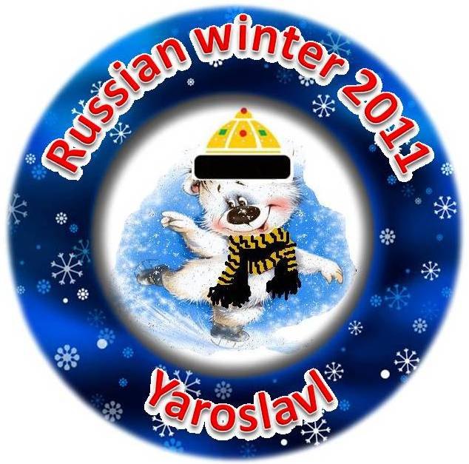
“Russian winter 2011”

A Non-Qualifying Competition
of Figure Skating for Children

REGULARS

Aims and targets

- to popularize and cultivate the amateur figure skating;
- to draw the public attention and organizations to the amateur level of figure skating;
- to inform all those concerned and interested in the amateur figure skating about the possibility to learn and master your figure skating skills in any age at any level;
- to inform about the possibility of any figure skater to participate in this kind of competitions;
- to stimulate the interest and development of any children amateur figure skating clubs,
- to communicate and to know more about figure skating traditions in other countries/

Date, location, organization of the competition

The competition is to be held on 25–27, February, 2011 on the skating-rink of “Zavolzhskiy” (Shkol’niy proezd, 13a) in Jaroslavl’ – Russia (apr. 260 km = 4 hours from Moscow by train or car). The program, the schedule of events and practices will be announced extra after 10, February, 2011.

The organization of the competition is carried out by the Organizing Committee with Chairman, Senior Judge and Senior Secretary in the head.

The Organizing Committee reserves the right to postpone or cancel the competition or to change the skating rink if needed.

ELIGIBILITY
This event is open for participation to all eligible skaters (in age of 6 – 16) who are in good standing with their National Figure Skating Association.
In case of equalizing the possibility of participants the Organizing Committee recommends participating those skaters who have practices not more then 3 times a week in their club’s schedule.
Skaters can enter only one level of Free skating. A skater can also enter other event but the level of other event must be in accordance to the level of Free skating.

Competitors
Any competitor is allowed to participate if he/she provided the following:

- before 1, February, 2011 – the Entry form (Form № 5) has to be sent

and after the acception of Organizing committee
- before the 5, February 2011 – Entry fee payments have to be done by bank transfer.

Foreigners will receive all payment information after receiving their Entry forms and Total lists
(Form № 6) and in case of receiving Russian visas in time they are recommended to take the decision about their participation in time.
The Organizing Committee recommends to arrive to Moscow not later then 24, February, 2011 and then to follow to Jaroslavl’ together with it in the morning of 25, February, 2011 by train.

EVENTS

The competition includes the following kinds of events:
- Free Skating
- Interpretative Program

Age Categories
The age dated on 6.03.2010.
The following age categories apply:
6–7 years, 8–10 years, 11–13 years, 14–16 years.

Based on the number of entries, some age categories may be combined.

Music

– is to be the only recording of good quality on a CD;
– is to be ready to start from the very beginning;
– is to be marked with the name, event entered, the level, age category;
– is to be turned in at Registration Desk to the Organizing Committee 2 hours before the beginning of the event and will be returned at the conclusion of the event;
– a skater must have a copy of CD near by during the start.

Registration and DRAWS

Draws by events will take place on the organizing meeting, which will be held the day before the first day of competitions on 26, February, 2011. The information about the time and the place will be in the schedule of competitions that will be sent additionally after 10, February, 2011.

Registration of participants will take place at the organizing meeting or not later then for 2 hours before the competition of the event.

Participants can receive any necessary information and assistance at the “Information Desk” that will work during the competition.

Judging

The new ISU judging system will be used for all events.

Suming up and awarding

The count of scores is done at every level in every event in each age category.
The winner with the best score gets the 1st place.
Awards, diplomas and small presents will be presented after competition ends in all events. All participants will get gold medals for their courage and desire to create.

Liability
The Organizers undertake no responsibility for damages or injuries suffered by the skaters or officials. The entries shall be accepted only on a condition that all entrants, their family members and officials shall be deemed to assume all risk of injury to their person and property resulting from, caused by or connected with the conducting and management of the competition.
The entrants shall sign the liability receipt (Form № 5).
Every participant of the competition must have the medical insurance that can be asked to show at registration.

EXPENSES
Travel expenses, board and accommodation will be charged by the participants.

Entry forms
The Entry form for every event with the originally signed liability receipt (Form № 5) is to be given untill 1, February, 2011.
to Gulia Vertebnaya:
Address: Moscow country, Krasnogorsk, Volokolamskoie st.,
All-Season Mountain-ski Center “Snej.Com” – Mondays and Thursdays 16.00 – 20.00.

It can be also send by e-mail to the Organizing Committee: silver-dream@inbox.ru

or by Fax: 007 495 564 91 83.

Contact phones: 007 926 117 92 13 – Marfa Khovanskaya

007 916 578 19 69 - Gulia Vertebnaya

ICE- PRACTICES
Ice-practices will be available for all competitors on competing skating-rinks. The exact schedule of the competitions will be sent in addition after 10, February, 2011.

You should include it in Total list (Form № 6) but not include to Your transferring payments. It’ll be paid after adopting the schedule of the competition, on Your arrival.

All requests for reservations must be mailed to Gulia Vertebnaya

e-mail: silver-dream@inbox.ru or Fax: 007 495 564 91 83.

COMPETITION ARENA
is full Olympic size rinks, 56 x 28 m, with plastic dashers.

ENTRY FEES
Entry fees are as follows:
First singles event = 60 Euros/pers = apr. 2500 rub/pers

Second singles event = 35 Euros/pers = apr. 1500 rub/pers

You should include it in Total list (Form № 6).

You should send the copy of payments certified by bank till 5, February, 2011 by
e-mail: silver-dream@inbox.ru or Fax: 007 495 564 91 83.
It’ll be the final confirmation of Your participation.

Late entries and payments will not be accepted. However under unusual conditions, late its may only be accepted at the discretion of the Organizing Committee and will carry an additional 20 Euro / 900 rub late entry fee.

REPAYMENTS
If the participant withdraws from the competition and if the Organizing Committee are notified before 1, February, 2011 (by the same e-mail and fax), the entrance fees will be refunded less a 20 Euro/900 rub processing charge.

Full refunds will be given if we are notified before the close of entries - 1, February, 2011.

After 10, February, 2011 no refunds will be given unless the event is not held.

If the competitor has an injury or illness, the competitor will need to send a letter signed by his/her physician showing inability to compete. And the Organizing Committee will refund all transferred payments withholding all expenses incurred.

A 20 Euro/900 rub charge will be made for all checks returned by the bank for any reason and payment must be made by cash, or transfer by bank.

Currency: Payment of fees must be in Rubles. For those coming from outside of Russia, please send the full sum (the Organising committee need to receive the whole sum).

ACCOMODATION
You can make the reservation yourself (directly): http://www.adm.yar.ru/1000Years/section.aspx?section_id=613
or You can use the help of the Organizing committee, which recommends all arriving participants the accommodation during the competition in the same hotel, where the Organizing committee is planning to stay.
The transfer from this hotel to the skating-rink will be organized during the competition.

TRANSFERS
The Organizing committee will advice participants Transfers 1, 4:

Transfer 1 (by train) – “Arriving – Departure”(Moscow – Jaroslavl’ – Moscow) = apr. 1200 rub/pers*
Transfer 4 (by bus) Recommended hotels - skating-rink - 2 roads = apr. 500 rub/pers*

* - Prices are approximately and may be changed at January, 2011.

It’s needed to make prepayments of Transfers 1, 4:
transfer 1 (100 % = 1200 rub/pers,
transfer 4 (50 % = 250 rub/pers )
on dates 1 – 10, February, 2011
after the confirmation of Your booking by the Organizing committee.

VISA SUPPORT

For the majority of the participants living in the territory of the EEC, and also in the territory of other countries it is necessary to receive the visa for entrance to Russian Federation. You can receive the visa in Russian Embassy which is located in the country of your residing.
Together with Moscow Figure-skating Federation we are ready to assist in registration of Russian visa to all those who need it for additional payment (apr 30 Euro = apr/ 1200 rub). You’ll receive the telex number in the Embassy and it’ll be needed only to collect all necessary papers and bring them to the Embassy.
Please, those who need Russian visas, fill up by PC the VISA-invitation form (Form 3) and give it back with copy of your passport not later than 1, February, 2011 by:
e-mail: silver-dream@inbox.ru or Fax: 007 495 564 91 83.
ENTERTAINMENT programs

Winter is a wonderful time for opening Russia!
You will have the opportunity to feel the beauty of old Russian towns in winter during the competition!

Please, don’t forget to include the information about Your booking of the entertainment program in
Total list (Form № 6).

1/ Sightseeing of Jaroslavl’ – the historical and architectural places, visiting of old Kremlin with
the animation program “Jaroslavl’s matchmaking”
(apr. 4 hours, by bus and feet)
- 26^{tth*}, February, 2011 (day-time)
The price: for the group 11 - 20 persons = 1500 rub/pers = apr. 35 euro/person**

The cost includes: guide, transport service by bus, the museum tickets, animation program

* - Dates are approximate and may be changed at January, 2011.
** - Prices are approximate and may be changed at January, 2011.

It’s needed to make the prepayment of Sightseeing of Jaroslavl’ :
(50 % = 750 rub/pers )
on dates 1–10, February, 2011
after the confirmation of Your booking by the Organizing committee.

GOOD LUCK!

YOU ARE WELLCOME TO RUSSIA – JAROSLAVL’!

